Study Planner and Exam Scheduler: Analysis Document (SRS)

1. Introduction
University students usually take four to six courses every semester. Each course has its own syllabus, assignments, quizzes, and midterms. Most of the time, students just write due dates in a phone calendar or on sticky notes. This shows when something is due, though it leaves out when they actually need to start studying for it. Because of this, tasks pile up in the same week and students end up cramming the night before an exam. Commercial apps like Notion or Todoist are flexible, but they take a lot of manual setup. They also don't split up study hours across the days before a deadline unless you pay for extra AI add-ons.

This project analyses, designs, and builds a desktop application in Java called the Study Planner and Exam Scheduler. Following the object-oriented software engineering method from Bruegge and Dutoit (2009), this Analysis Document acts as our Software Requirements Specification (SRS). It serves as an agreement between our dev team and the instructor (IEEE Computer Society, 1998). The goal is to build a clean, practical system that helps students organise their coursework without getting stuck in complicated scheduling maths or hourly time slots.

2. Overview
The Study Planner and Exam Scheduler is a standalone desktop program for uni students who want a simple way to manage their workload. In this system, a student registers their current semester courses and attaches graded tasks to each one, like assignments, quizzes, and exams. For every task, the student puts in a due date and an estimated total number of study hours needed to finish or prepare for it.

Forcing users to drag and drop tasks into specific clock hours like 2:00 PM to 4:00 PM rarely works in real life, since students don't stick to it anyway. Instead, our system uses a day-based approach. How it goes is the scheduling engine counts the calendar days left between today and the due date. Then it spreads the estimated study hours evenly across those days using simple division. It also checks for basic scheduling conflicts, like having two exams on the exact same date, or having the total study hours on one day go over the student's daily limit (for example, more than 5 hours a day). When the user opens the app, a main dashboard shows overdue and upcoming tasks, lets them tick off daily study blocks as they finish them, and shows a workload summary for each course. Everything is saved locally on the user's computer in a small SQLite database or a single JSON file, so it doesn't need an internet connection or cloud server.

3. Functional Requirements
To keep the project doable within our semester deadline while still showing solid object-oriented analysis and design (Larman, 2004; Sommerville, 2016), the functional requirements are split into five main areas, as follows:
- Course and Task Management (FR1): The system lets the student create, view, edit, and delete courses using a course code (like CS302) and a course title. Under each course, the student can add, edit, or remove academic items like an Assignment, a Quiz, or an Exam. Each item needs a title, a parent course, a due date stored as a calendar date (LocalDate), and an estimated total study hours value.
- Automated Daily Study Distribution (FR2): Whenever a task gets added or updated, the system automatically makes daily study blocks between the start date (which defaults to today) and the due date. The daily study load for a task is worked out by dividing the remaining study hours by the calendar days left before the deadline. The system skips clock times and hourly slots on purpose so the schedule stays flexible.
- Conflict Detection and Flagging (FR3): The system runs basic date checks whenever the schedule is made or changed. Specifically, the program flags a warning if two or more Exam items land on the exact same date, or if the total study hours across all tasks on a single day go over the user's daily study limit (which defaults to 5.0 hours per day).
- Progress Tracking and Dashboard Alerts (FR4): The student can mark individual daily study blocks as done. Ticking a block off subtracts those hours from the task's remaining hours and updates the overall progress. When the app starts up, the dashboard highlights overdue tasks in red and upcoming deadlines (within the next 3 days) in yellow.
- Workload Summary and Local Persistence (FR5): The system gives a summary screen showing total completed tasks and remaining study hours grouped by course. All courses, tasks, and daily study blocks save and load automatically from a local SQLite database file (or a single local JSON file), so user progress stays saved after closing the window.

4. Nonfunctional Requirements
The nonfunctional requirements follow standard software quality rules (IEEE Computer Society, 1998; Sommerville, 2016) to make sure the app is reliable and easy for our group to maintain. For Implementation and Portability, the app is built entirely in Java (JDK 17 or higher) using standard object-oriented rules like inheritance, encapsulation, and polymorphism (Bruegge & Dutoit, 2009). Since it runs on the Java Virtual Machine and uses local storage, it runs just fine across Windows, macOS, and Linux laptops with no extra setup.

In terms of Performance and Usability, schedule updates and conflict checks have to finish in under one second for a normal semester load of up to 10 courses and 100 academic items. Since the maths only uses basic date calculations and division on small lists, this is very easy to hit. The interface is built with standard Java GUI tools (JavaFX or Swing) and clear visual cues, so a student can see their daily workload without reading a manual.

Finally, for Persistence and Maintainability, all user data is stored locally inside the project folder using either the sqlite-jdbc driver or standard JSON files. There are no network or outside server links, which avoids lag and privacy issues. The code separates the user interface, business logic, and data storage into different packages. That way, team members can work on separate classes on GitHub without constant merge conflicts.

5. System Models

5.1. Use Case Model
During our first team brainstorming session, our early Use Case Diagram draft only had two use cases (Add Course and Generate Schedule). While that showed the main actor (Student), it missed a few key parts from our problem statement, like adding different assessment types, ticking off daily progress, and checking the course summary.
Following standard UML use case modelling practices (Booch et al., 2005), the Student actor in our updated model uses six main use cases inside the Study Planner System boundary, as follows:
Here is a table showing the use cases:
Use Case Name | Participating Actor | Brief Description and Relationships
UC1: Manage Courses | Student | Lets the student add, edit, or delete semester courses (course code and name).
UC2: Manage Academic Items | Student | Lets the student add, edit, or delete Assignments, Quizzes, and Exams with due dates and study hours.
UC3: Generate Study Schedule | Student | Divides study hours evenly across calendar days up to the due date. Includes UC4: Detect Schedule Conflicts («include»).
UC4: Detect Schedule Conflicts | System / Student | Automatically checks for same-day exams and days where total study hours pass the daily limit.
UC5: Track Daily Study Progress | Student | Marks daily study blocks as done and refreshes the dashboard overdue and upcoming highlights.
UC6: View Workload Summary | Student | Shows a breakdown per course of completed tasks and remaining study hours.

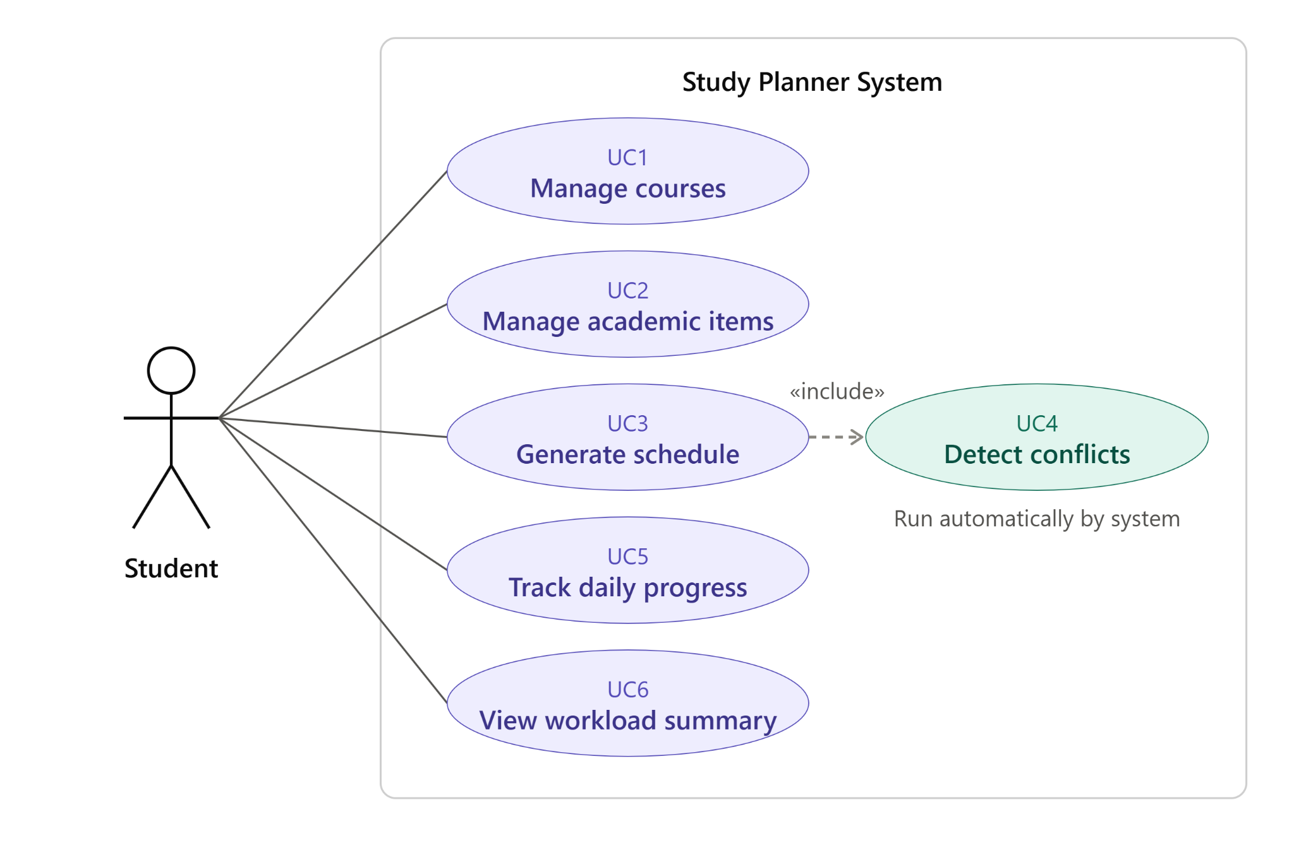
(Above is the Use Case Diagram for our system)

5.2. Dynamic Models
Now we get to the dynamic models, which show how objects work together over time (Booch et al., 2005; Larman, 2004). We looked at the order of events when a student adds coursework and builds their study plan. In our first sequence diagram draft, addCourse(courseCode) and requestGenerateSchedule() were merged into one sequence, and the engine called a vague optimiseSchedule() method. After looking it over, we fixed two things. First, schedules are made from AcademicItem tasks rather than empty course codes. Second, we swapped the vague method call for simple date division and conflict checks so the code stays easy to write.

Sequence 1: Task Creation and Schedule Generation (Lifelines: Student, UI: MainDashboard, Engine: ScheduleEngine, Database: StorageManager)
1. Student calls addAcademicItem(courseCode, title, type, dueDate, estHours) on UI: MainDashboard.
2. UI: MainDashboard calls saveItem(item) on Database: StorageManager, which returns confirmSaved().
3. Student triggers requestGenerateSchedule() on UI: MainDashboard.
4. UI: MainDashboard calls generateSchedule(maxDailyHours) on Engine: ScheduleEngine.
5. Engine: ScheduleEngine calls getCoursesAndTasks() on Database: StorageManager and gets taskList.
6. Engine: ScheduleEngine runs a self-call divideHoursAcrossDays(today, dueDate) to create daily StudyBlock objects.
7. Engine: ScheduleEngine runs a self-call detectDateConflicts(taskList, studyBlocks, maxDailyHours) to flag same-day exams or daily hour overloads.
8. Engine: ScheduleEngine returns studyBlocksAndWarnings to UI: MainDashboard, which calls displayScheduleAndAlerts() for the Student.

Sequence 2: Marking a Daily Study Block Complete
When the Student ticks off a daily StudyBlock on the dashboard, UI: MainDashboard calls markBlockComplete(blockId) on ScheduleEngine. The engine sets isDone = true on the StudyBlock, takes allocatedHours off the parent AcademicItem remaining study hours, calls StorageManager.updateProgress(), and refreshes the overdue and upcoming highlights on the dashboard.

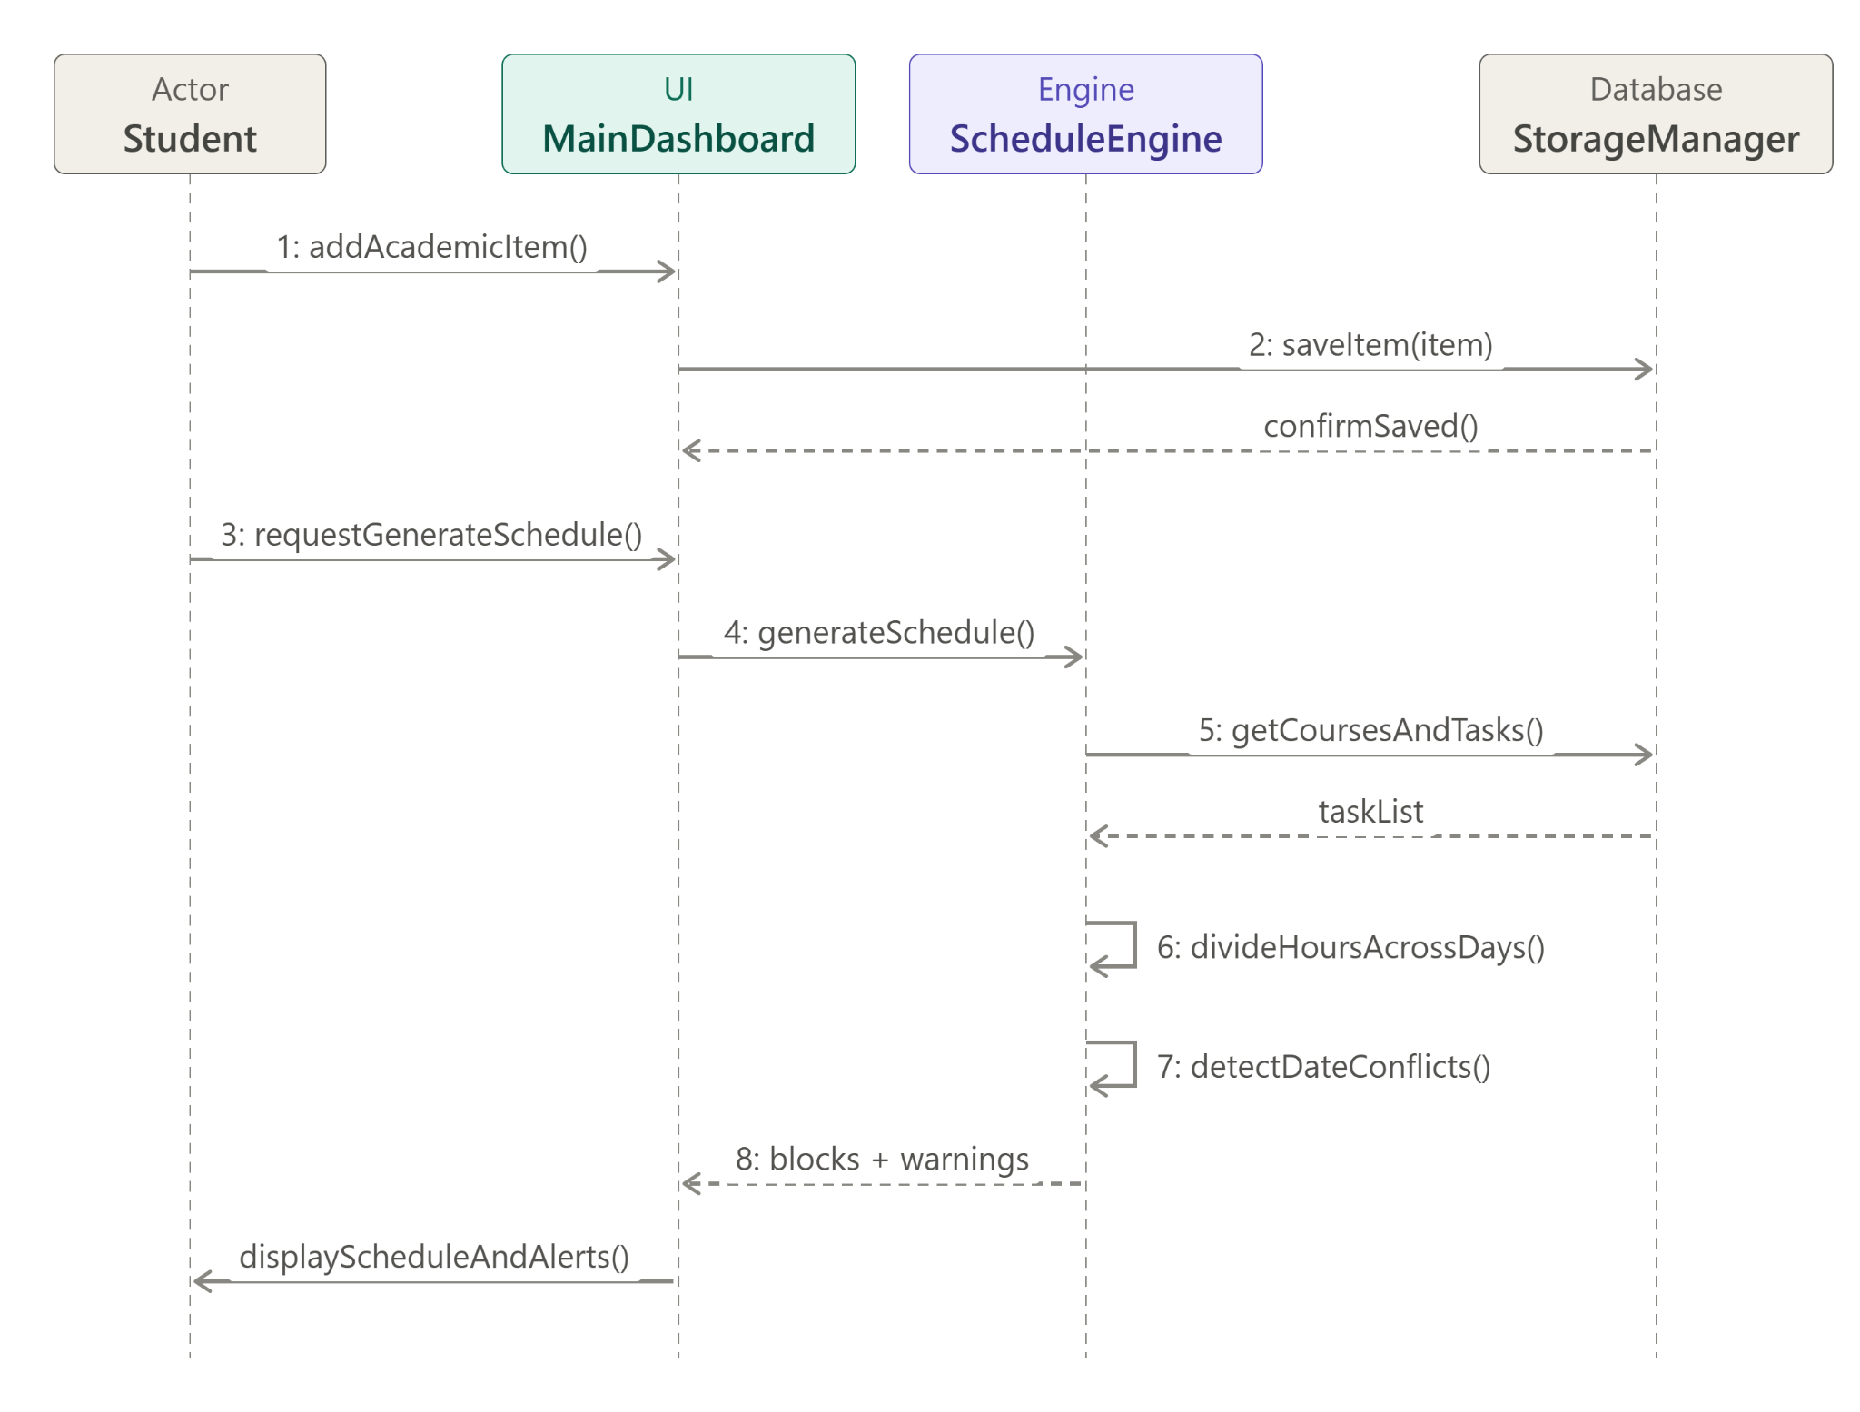
(Above is the Sequence Diagram for our system)

5.3. Object and Class Model
Our first class diagram draft had an abstract AcademicItem superclass with Exam and Assignment subclasses connected to a ScheduleEngine. Using the entity-boundary-control setup from Bruegge and Dutoit (2009), we improved the Object and Class Model in four ways to keep the Java code simple:
1. Added a Quiz subclass under AcademicItem so all three required task types (Assignment, Quiz, Exam) use inheritance and polymorphism properly.
2. Changed deadline from LocalDateTime to java.time.LocalDate since our system only uses calendar days rather than clock times.
3. Added a Course class (1-to-many composition with AcademicItem) and a StudyBlock class (1-to-many association from AcademicItem) to track daily study chunks and completion checkboxes.
4. Added StorageManager for local SQLite and JSON saving, and replaced generateMockSchedule() in ScheduleEngine with actual scheduling and conflict-check methods.

Class Name | Type / Stereotype | Key Attributes | Key Operations (Methods)
Course | Entity Class | courseCode: String; courseName: String; items: List of AcademicItem | addAcademicItem(item): void; getRemainingCourseHours(): double; getCompletedTaskCount(): int
AcademicItem | «abstract» Superclass | id: String; title: String; dueDate: LocalDate; estimatedHours: double; completedHours: double; isCompleted: boolean | getRemainingHours(): double; calculateDailyHours(today: LocalDate): double; markCompleted(): void; getItemCategory(): String {abstract}
Assignment | Concrete Subclass | complexityLevel: int | getItemCategory(): String; calculateDailyHours(today: LocalDate): double
Quiz | Concrete Subclass | chapterNumber: int | getItemCategory(): String; calculateDailyHours(today: LocalDate): double
Exam | Concrete Subclass | examDurationMinutes: int; weightPercentage: double | getItemCategory(): String; calculateDailyHours(today: LocalDate): double
StudyBlock | Entity Class | blockId: String; assignedDate: LocalDate; allocatedHours: double; isDone: boolean; parentItem: AcademicItem | markBlockDone(): void
ScheduleEngine | Control Class | maxDailyHoursLimit: double | generateDailyBlocks(items): List of StudyBlock; detectConflicts(items, blocks): List of String
StorageManager | Boundary / DAO | dbPathOrJsonFile: String | saveAll(courses): void; loadAll(): List of Course

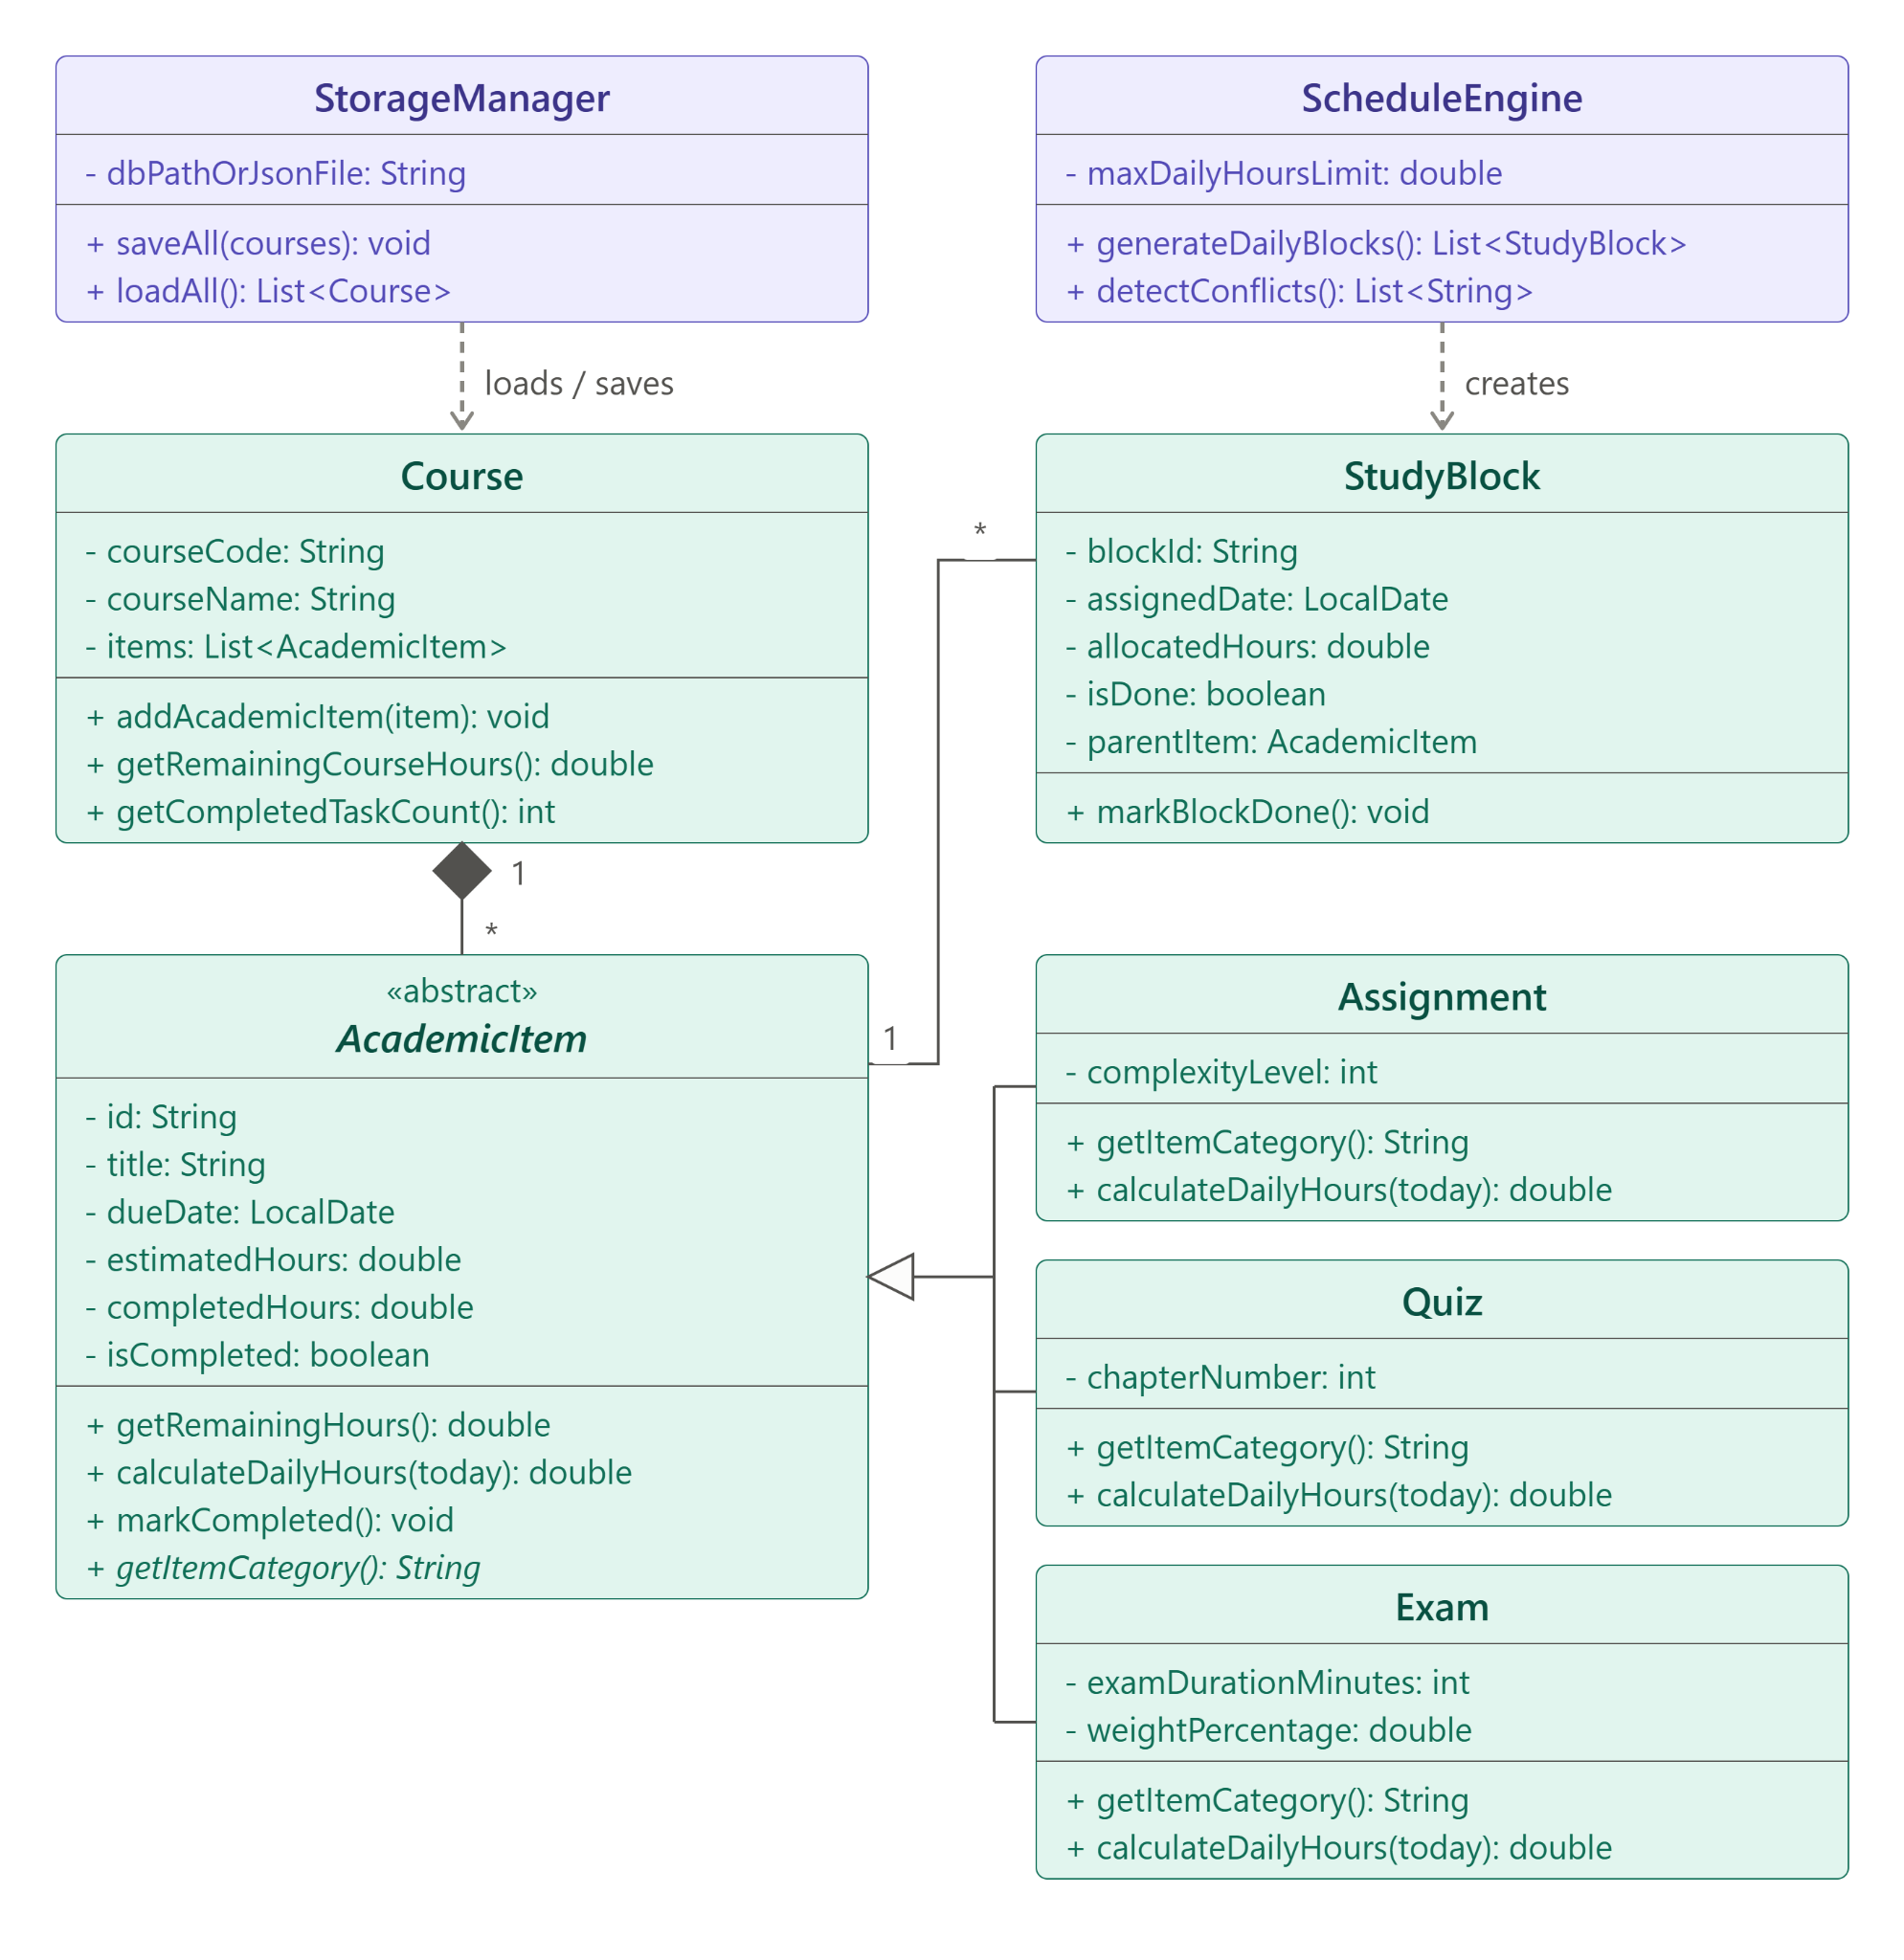
(Above is the Class Diagram for our system)

5.4. User Interface: Navigational Paths and Screen Mock-ups
To keep the GUI code simple in JavaFX or Swing, the interface sits inside a single main window with three tabs so the user never gets lost in deep pop-up menus:
1. Dashboard and Daily Plan Tab (Home Screen): This is the first screen when the app opens. At the top, a Conflict and Alert Banner highlights overdue tasks in red, tasks due within 3 days in yellow, and any conflict warnings (like "Conflict Warning: 2 Exams scheduled on 2026-11-20" or "Overload Warning: Nov 18 requires 6.5 hrs, passing your 5.0 hr daily limit"). Below that is a table of Today's and Upcoming Study Blocks. Each row shows the Date, Course Code, Task Title, Allocated Hours (like 1.5 hrs), and a Mark Complete checkbox.
2. Courses and Tasks Manager Tab: Found by clicking the second tab at the top. The left panel shows a list of added courses with an Add Course button. Clicking a course fills the right table with all its Assignments, Quizzes, and Exams. At the bottom, there is a simple input bar for Task Title, Type dropdown (Assignment, Quiz, Exam), Due Date picker, and Estimated Total Hours.
3. Workload Summary Tab: Found on the third tab. It shows a clean table with one row per course, listing the Course Code, Total Tasks, Completed Tasks, and Total Remaining Study Hours, along with a number box to change the user's Max Daily Study Hours Limit.

6. Glossary and References

Glossary (class definitions and such)
• AcademicItem: The abstract base class for any graded coursework item (Assignment, Quiz, or Exam) that needs study time before a due date.
• Daily Study Limit: The max number of study hours a student wants to do in one calendar day before the system flags an overload warning.
• Schedule Conflict: A warning triggered when two or more exams land on the same date, or when the study blocks on a single day add up to more than the Daily Study Limit.
• StudyBlock: A single day's chunk of study hours for a specific task, worked out by dividing the task's remaining hours by the days left until its deadline.

References
Booch, G., Rumbaugh, J., & Jacobson, I. (2005). The Unified Modelling Language user guide (2nd ed.). Addison-Wesley Professional. https://www.pearson.com/en-us/subject-catalog/p/unified-modeling-language-user-guide-the/P200000000144/9780134852157

Bruegge, B., & Dutoit, A. H. (2009). Object-oriented software engineering using UML, patterns, and Java (3rd ed.). Prentice Hall. https://www.pearson.com/en-us/subject-catalog/p/object-oriented-software-engineering-using-uml-patterns-and-java/P200000003319/9780133002096

IEEE Computer Society. (1998). IEEE recommended practice for software requirements specifications (IEEE Std 830-1998). Institute of Electrical and Electronics Engineers. https://doi.org/10.1109/IEEESTD.1998.88286

Larman, C. (2004). Applying UML and patterns: An introduction to object-oriented analysis and design and iterative development (3rd ed.). Prentice Hall. https://www.pearson.com/en-us/subject-catalog/p/Larman-Applying-UML-and-Patterns-An-Introduction-to-Object-Oriented-Analysis-and-Design-and-Iterative-Development-3rd-Edition/P200000000422

Sommerville, I. (2016). Software engineering (10th ed.). Pearson Education. https://www.pearson.com/en-us/subject-catalog/p/Sommerville-Software-Engineering-10th-Edition/P200000003258

